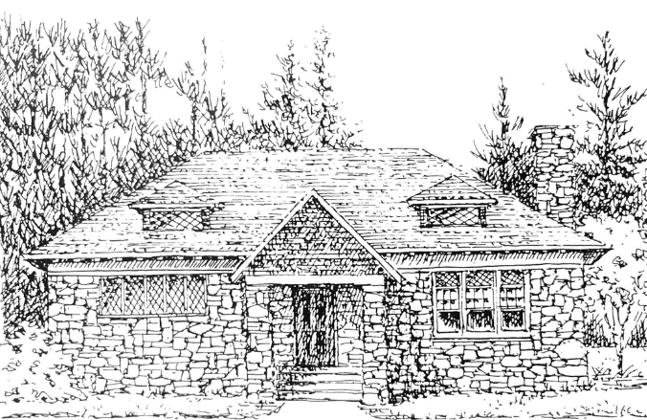

Windham Museum Trustees Agenda
February 11th, 2026

- Vote to accept the minutes of the January14th meeting.
- Update on Scavenger Hunt planning with the Library - Derek

Workshop:
- Adding/labelling items to be placed in new tall display cases.
- Completing intake forms, photographing and entering into CatalogIt the Cobbetts Pond plot plan, the scrapbooks from the Women’s Service Club of Windham, and the records of the Windham Antiquarian Society donated by Peter Griffin.
- Stowing items in plastic storage bins.
- Perhaps for a later date – reviewing of all items in the metal storage cases. Some items appear to have no identification and have not been entered in CatalogIt.

Upcoming Dates:
- Feb.14 – Open House 12:30-2:00
- March 11th meeting – 7:00 (Jean away)
- April 8th meeting - 7:00
- April 12 – Open House, 2:00-4:00
- May 13th meeting -7:00
- June 7th - Open House, 2:00-4:00
- June 10th meeting – 7:00
- July 8th meeting – 7:00
- August 9 - Open House, 2:00-4:00
- August 12th meeting – 7:00
- September 9th meeting – 7:00
- October 11 - Open House, 2:00-4:00
- October 14th meeting – 7:00
- December 5 (tree lighting) 2:30-5:00
- No December meeting

