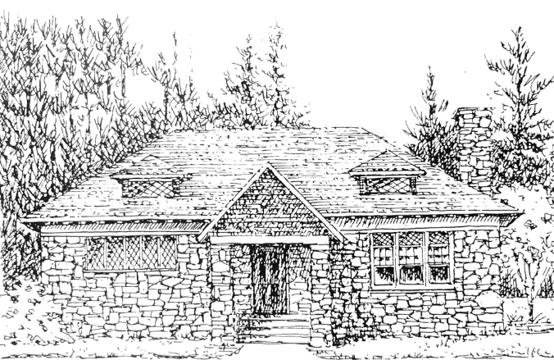

Windham Museum Trustees Agenda
January 14th, 2026

- Vote to accept the minutes of the November 12th meeting.
- Correspondence:
  - We have received a batch of wonderful thank you notes from third graders who visited the Museum in November.
  - Denise Paige Lietz of South Berwick, Maine sent a property plan of a group of camps on Cobbetts Pond Road across the street from the Town Beach. Her grandparents had a camp there and she found it among her parents’ papers.
- Update on Scavenger Hunt planning with the Library - Derek

Workshop:
- Adding/labelling items to be placed in new tall display cases.
- Completing intake forms, photographing and entering into CatalogIt the Cobbetts Pond plot plan and the scrapbooks from the Women’s Service Club of Windham (on the oak table).
- Perhaps for a later date – review of all items in the metal storage cases. Some items appear to have no identification and have not been entered in CatalogIt.

Upcoming Dates:
- February 4th, 11:15 a.m. Women’s Service Club of Windham Meeting at A.J. Letizio, 55 Enterprise Drive.
- February 11th Meeting
- March 11th meeting – Jean away

